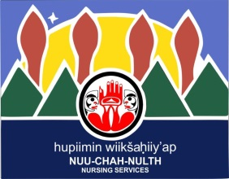
Nuu-chah-nulth Tribal Council Nursing Referral Form

The Nuu-chah-nulth Tribal Council (NTC) Nursing Program provides a comprehensive Maternal, Child and Home and Community Care Nursing Service to these Nuu-chah-nulth Nations:
Ditidaht, Tseshaht, Hupacasath, Huu-ay-aht, Uchucklesaht, Ahousaht, Hesquiaht, Tla-o-qui-aht, Ucluelet and Toquaht
To: Robyn Clarke, Community Health Nurse Clinical Leader
OR
Jeannette Tremblay, Home Care Nurse Clinical Leader
Fax #: 250-723-5396
Patient Information:  NAME:  DOB:  PHN:  ADDRESS:  PHONE #: | Referring Source:  NAME:  CLINIC:  PHONE #:
Reason for referral: | Referring to:  □ Home Care  □ Community Health Nursing  □ Prenatal/ Postnatal Care
Our nurses can provide follow up and monitoring of your patients, be it pregnancy or chronic complex conditions.
We are working with VIHA towards creating a single referral form, until that time please use our confidential fax line for all referrals of Nuu-chah-nulth clients to the attention of:
Robyn Clarke, Community Health Nurse Clinical Leader (250) 723-5396
AND/OR
Jeannette Tremblay, Home Care Nurse Clinical Leader (250) 723-5396

